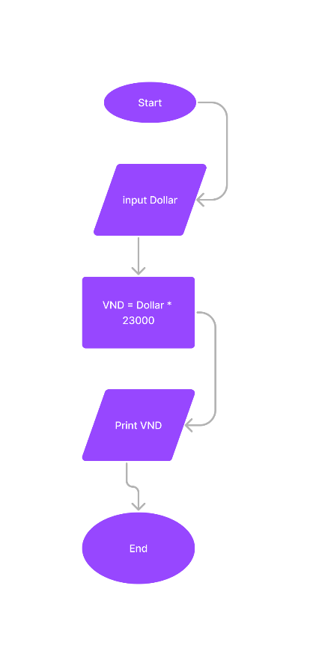Begin

Input Dollar

VND = Dollar \* 23000

Print VND

End